H.T No
Regulations:
A20

Sreenidhi Institute of Science and Technology
(An Autonomous Institution)
Code No:8AC41 Date: 19-September-2024 (FN)

B.Tech II-Year I- Semester External Examination, September-2024 (Supplementary)
BASIC ELECTRICAL ENGINEERING (CSE and IT)

Time: 3 Hours Max.Marks:70

Note: a) No additional answer sheets will be provided.
b) All sub-parts of a question must be answered at one place only, otherwise it will not be valued.
c) Missing data can be assumed suitably.

Bloom's Cognitive Levels of Learning (BCLL)

Remember | L1 | Apply | L3 | Evaluate | L5
Understand | L2 | Analyze | L4 | Create | L6

Part - A Max.Marks:20
Answer all QUESTIONS

 |  | BCLL | CO(s) | Marks
1 | State Kirchhoff’s Law. | L1 | CO1 | [2M]
2 | State Thevenin’s theorem | L1 | CO2 | [2M]
3 | Classify different types of DC Generators | L3 | CO3 | [2M]
4 | Define Voltage regulation | L1 | CO4 | [2M]
5 | Draw the 3 Ø Delta connection, and write relation between line and phase voltage in balanced system | L2 | CO5 | [2M]
6 | Define recording instruments | L1 | CO6 | [2M]
7 | State faradays law of electromagnetic induction principle | L1 | CO1 | [2M]
8 | Explain how iron losses can be reduce in Transformer | L2 | CO3 | [2M]
9 | Write applications of MI type instruments | L1 | CO5 | [2M]
10 | Define asynchronous motor? | L2 | CO6 | [2M]
Part – B Max.Marks:50
ANSWER ANY FIVE QUESTIONS. EACH QUESTION CARRIES 10 MARKS.

 |  |  | BCLL | CO(s) | Marks
11. | a) | Derive the expressions for Star-Delta transformations | L2 | CO1 | [5M]
 | b) | Find the current through R_{L} in figure using Thevenin’s theorem  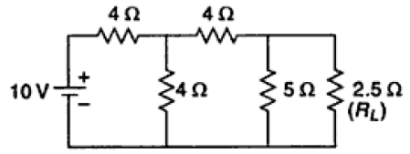 | L3 | CO1 | [5M]
12. | a) | Determine total impedance, and current in each branch  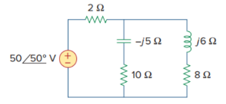 | L3 | CO2 | [5M]
 | b) | Derive average and RMS value of current for a sinusoidal ac voltage waveform. | L2 | CO2 | [5M]
13. | a) | With neat diagram, explain the construction of DC machine | L2 | CO3 | [5M]
 | b) | A four-pole generator, having wave-wound armature winding has 300 conductors. What will be the voltage generated in the machine when driven at 1500 rpm assuming the flux per pole to be 8.0 m Wb? | L3 | CO3 | [5M]
14. | a) | A 20kVA, 50Hz, 2000/200V distribution transformer have data as follows  OC test with HV open circuited: 200V; 4A; 120W  SC test with LV short circuited: 60V; 10A; 300W  Calculate  a) With full load on the LV side at rated voltage, calculate the excitation voltage and the voltage regulation on the HV side. The load power factor is 0.8 lagging | L3 | CO4 | [5M]
 | b) | Derive EMF equation of a single-phase transformer | L2 | CO4 | [5M]
15. | a) | Derive voltage and current equations for a 3-ph balanced delta connected load | L2 | CO5 | [5M]
 | b) | Explain the operation of 3-p induction motor | L2 | CO5 | [5M]
16. | a) | Explain the working principle of a PMMC instrument. | L2 | CO6 | [5M]
 | b) | A moving coil ammeter has a fixed shunt of 0.02Ω with a coil resistance of R=1000Ω, potential difference of 500mV across it, full scale deflection is obtained such that  a.To what shunt current does this correspond?  b. calculate value of R with given full scale deflection when shunted current is 10A, 75A. | L3 | CO6 | [5M]
17. | a) | Calculate the voltage across the 10Ω resistor shown in fig  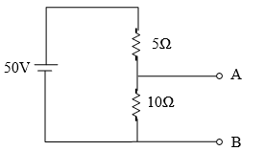 | L3 | CO1 | [4M]
 | b) | Illustrate 1-ph series RL circuit with neat phasor diagram | L2 | CO2 | [3M]
 | c) | Derive Torque equation of a DC Motor | L2 | CO3 | [3M]
18. | a) | Outline OC test conduction process in a Transformer manufacturing industry | L5 | CO4 | [4M]
 | b) | Discuss why induction motor is called asynchronous motor? | L2 | CO5 | [3M]
 | c) | Derive expression for extinction of range of MC type meters | L2 | CO6 | [3M]

-- 00 -- 00 –

